Quiz No.03



Theory of Automata

Instructor Name: Mr. Tahir Iqbal Program: BSCS 4A/4B (Fall-2023)

*Question No.1*

**Given two finite automata FA1 and FA2 accepting the respective languages L1 and L2**

**FA1**

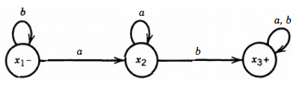

**FA2**

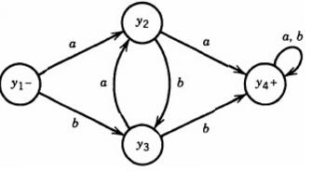

**Construct the following finite automaton**

1. FA1+FA2
2. FA1FA2
3. (FA1)*

**Good Luck**